Request for Statements of Interest

Funding Opportunity Announcement

Federal Awarding Agency:

U.S. Army Corps of Engineers,

Engineer Research and Development Center

3909 Halls Ferry Road

Vicksburg, MS 39180-6199

Funding Opportunity No: W81EWF-20-SOI-0008

CFDA No: 12.630

Statutory Authority: 10 USC 2358

Program Title: Collier County Coastal Storm Risk Management Feasibility Study for Hydrodynamic Modeling and Initial Water Quality Evaluations

Announcement Type: Initial announcement

Issue Date: 2 April 2020

Statement of Interest/Qualifications Due Date: 1 May 2020, 1600 hrs, Central

Full Application Package Due Date, if Invited: 22 May 2020, 1600 hrs, Central

Estimated Total Funding: $250,000.00 is available for this one year effort.

Estimated Number of Awards: One award

Section I: Funding Opportunity Description

Background:

Collier County and the Norfolk District, U.S. Army Corps of Engineers (USACE), are partnering to conduct a Coastal Storm Risk Management (CSRM) Study to determine the Federal interest and feasibility of alternatives to mitigate coastal flood risk in Collier County, Florida. The CSRM Study is in the Feasibility Study (FS) phase in which alternatives are proposed and developed to conceptual/preliminary design level, benefit/cost analyses are conducted, and environmental studies are completed to comply with the National Environmental Policy Act (NEPA). The magnitude of the feasibility study will require an Environmental Impact Statement (EIS).
A component of the FS / EIS is the analysis of expected impacts of certain proposed alternatives on tidal circulation and water quality in local waters, tidal rivers, streams and embayments in Collier County, including but not limited to those around Naples and Marco Island. These waters are shown (Figure 1). The purpose of the modeling is to support determination of whether the proposed alternatives will have significant impacts on circulation and water quality, and if so, to what degree and what potential mitigation actions might be applied required.
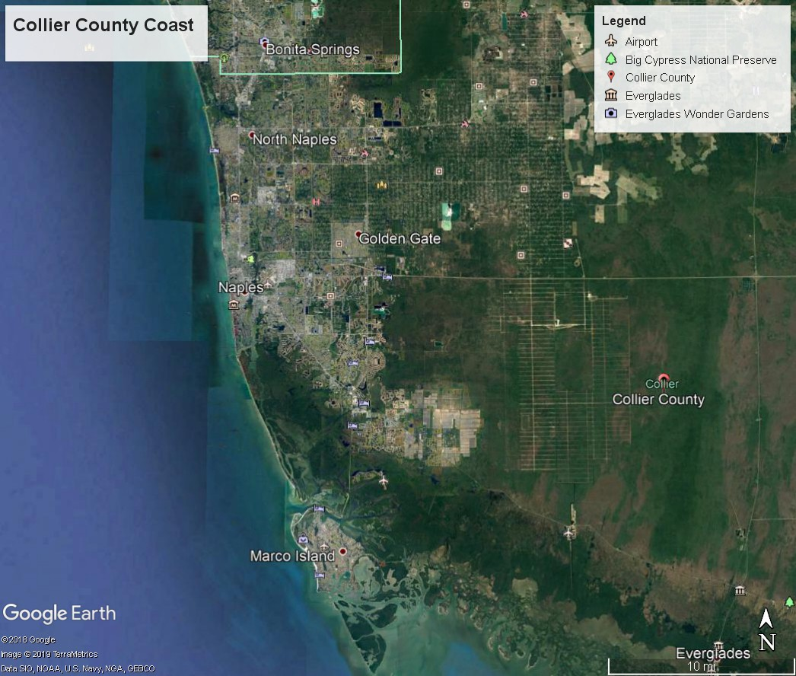

Figure 1. Collier County and associated nearshore waters and embayments.

Brief Description of Anticipated Work:

Objective 1: Participate in the development of the components of the FS / EIS.

Objective 2: Compile existing data and pertinent literature required to support the hydrodynamic and water quality modeling and analyses necessary as a component of the FS / EIS.

Objective 3: Hydrodynamic modeling of the nearshore waters of Collier County, Florida will be performed to support the efficient and stable simulation of processes in these waters.

Objective 4: Hydrodynamic modeling and analysis of circulation, flushing, and transport of conservative constituents will be performed to support the formulation and evaluation of alternative(s) – as proposed by USACE – for mitigating coastal flooding impacts in Collier County. Alternatives include beach nourishment and dune restoration along most of Collier County beaches, flood gate at Bonita Beach Road with an associated floodwall along Bonita Beach Road, flood gate and wall along Seagate Drive, tide gates with associated pump stations and structural tie-ins to land at Doctor’s and Wiggin’s passes, a floodwall along a significant portion of the Tamiami Trail Road with a flood gate on the Gordon River.

Successful applicants should have expert knowledge and work experience in coastal Florida waters. The candidates should have prior experience with hydrodynamic modeling, preferably along the Florida coast, and associated water quality parameter modeling with sufficient expertise to model the impacts of proposed coastal storm protective features. The candidates will also be required to submit (1) draft report and one (1) final report for each year the project is monitored. A final objective will be to publish the reports, modified as needed, in a peer-review science journal for the widest dissemination of the results throughout the practicing restoration community as possible.

Public Benefit:

The results of the hydrodynamic and water quality modeling will inform the planning and design of structural features to protect Collier County, including both natural resources and the human population and associated infrastructure from coastal storms.

Section II: Award Information

Responses to this Request for Statements of Interest will be used to identify potential investigators for studies to be sponsored by the Norfolk District and the Engineer Research and Development Center to provide hydrodynamic and sediment transport modeling to support selected alternatives in the draft study/EIS and assess their potential impacts on local ecosystem features and local waters. The estimated level of funding for FY20 is approximately $250,000.00 for a one year modeling effort and it is expected that the modeling can be done in one year post award. Total funding will not exceed $250,000.00 over the life of this cooperative agreement.

Government Involvement:

The Government will work cooperatively with the investigator to identify issues the protocol must address, provide maps with designs of proposed features and associated coordinates for the modeling effort, and other maps as needed. The Government may also assist in data analysis review, and will review/provide comment to draft reports. Government personnel may also assist the contractor in rendering the report(s) into appropriate format for publication in a peer-review scientific journal.

Section III: Eligibility Information
Eligible Applicants –
1. This opportunity is restricted to non-federal partners of the Piedmont - South Atlantic Coast or South Florida - Caribbean Cooperative Ecosystems Studies Unit (CESU) units.

- Cost Sharing – This action will be 100% funded by USACE.

Section IV: Application and Submission Information – Two Phase Process

Phase I: Submission of a Statement of Interest/Qualifications.

- Materials Requested for Statement of Interest/Qualifications:
  - Please provide the following via e-mail attachment to: Melissa.A.Keen@usace.army.mil
(Maximum length: 2 pages, single-spaced 12 pt. font).

1. Name, Organization and Contact Information

2. Brief Statement of Qualifications (including):
      - Biographical Sketch,
      - Relevant past projects and clients with brief descriptions of these projects,
      - Staff, faculty or students available to work on this project and their areas of expertise,
      - Any brief description of capabilities to successfully complete the project you may wish to add (e.g. equipment, laboratory facilities, greenhouse facilities, field facilities, etc.).

Note: A proposed budget is NOT requested at this time.

The administrative point of contact is Melissa Keen, 601-634-4880; melissa.a.keen@usace.army.mil

- Statement of Interest/Qualifications shall be submitted NO LATER THAN 1 May 2020, 1600 hrs, Central

Based on a review of the Statements of Interest received, an investigator or investigators will be invited to move to Phase II which is to prepare a full study proposal. Statements will be evaluated based on the investigator’s specific experience and capabilities in areas related to the study requirements.

- Phase II: Submission of a complete application package to include a full technical proposal including budget, if invited.

Address to Request Application Package
The complete funding opportunity announcement, application forms, and instructions are available for download at Grants.gov.

The administrative point of contact is Melissa Keen, 601-634-4880; melissa.a.keen@usace.army.mil

- Content and Form of Application Submission
All mandatory forms and any applicable optional forms must be completed in accordance with the instructions on the forms and the additional instructions below.
  - SF 424 R&R - Application for Federal Assistance
  - Full Technical Proposal – Discussion of the nature and scope of the research and technical approach. Additional information on prior work in this area, descriptions of available equipment, data and facilities, and resumes of personnel who will be participating in this effort should also be included.
  - Cost Proposal/Budget – Clear, concise, and accurate cost proposals reflect the offeror’s financial plan for accomplishing the effort contained in the technical proposal. As part of its cost proposal, the offeror shall submit cost element breakdowns in sufficient detail so that a reasonableness determination can be made. The SF 424 Research & Related Budget Form can be used as a guide. The cost breakdown should include the following, if applicable:
- Direct Labor: Direct labor should be detailed by level of effort (i.e. numbers of hours, etc.) of each labor category and the applicable labor rate. The source of labor rates shall be identified and verified. If rates are estimated, please provide the historical based used and clearly identify all escalation applied to derive the proposed rates.
- Fringe Benefit Rates: The source of fringe benefit rate shall be identified and verified.
- Travel: Travel costs must include a purpose and breakdown per trip to include destination, number of travelers, and duration.
- Materials/Equipment: List all material/equipment items by type and kind with associated costs and advise if the costs are based on vendor quotes and/or engineering estimates; provide copies of vendor quotes and/or catalog pricing data.
- Subrecipient costs: Submit all subrecipient proposals and analyses. Provide the method of selection used to determine the subrecipient.
- Tuition: Provide details and verification for any tuition amounts proposed.
- Indirect Costs: Currently the negotiated indirect rate for awards through the CESU is 17.5%.
- Any other proposed costs: The source should be identified and verified.

Application package shall be submitted NO LATER THAN 22 May 2020, 1600 hrs, Central

- Submission Instructions
Applications may be submitted by mail, e-mail, or Grants.gov. Choose ONE of the following submission methods:

  - E-mail:
Format all documents to print on Letter (8 ½ x 11”) paper. E-mail proposal to melissa.a.keen@usace.army.mil

  - Grants.gov: https://www.grants.gov/:
Applicants are not required to submit proposals through Grants.gov. However, if applications are submitted via the internet, applicants are responsible for ensuring that their Grants.gov proposal submission is received in its entirety.

All applicants choosing to use Grants.gov to submit proposals must be registered and have and account with Grants.gov. It may take up to three weeks to complete Grants.gov registration. For more information on registration, go to https://www.grants.gov/web/grants/applicants.html.

Section V: Application Review Information

- Peer or Scientific Review Criteria: In accordance with DoDGARS 22.315(c), an impartial peer review will be conducted. Subject to funding availability, all proposals will be reviewed using the criteria listed below (technical and cost/price). All proposals will be evaluated under the following two criteria which are of descending importance.

a. Technical (items i. and ii. are of equal importance):
i. Technical merits of proposed R&D.
ii. Potential relationship of proposed R&D to DoD missions.

b. Cost/Price: Overall realism of the proposed costs will be evaluated.

2. Review and Selection Process
a. Categories: Based on the Peer or Scientific Review, proposals will be categorized as Selectable or Not Selectable (see definitions below). The selection of the source for award will be based on the Peer or Scientific Review, as well as importance to agency programs and funding availability.

- Selectable: Proposals are recommended for acceptance if sufficient funding is available.

ii. Not Selectable: Even if sufficient funding existed, the proposal should not be funded.

Note: The Government reserves the right to award some, all, or none of proposals. When the Government elects to award only a part of a proposal, the selected part may be categorized as Selectable, though the proposal as a whole may not merit such a categorization.

b. No other criteria will be used.

c. Prior to award of a potentially successful offer, the Grants Officer will make a determination regarding price reasonableness.

Section VI: Award Administration Information
- Award Notices
Written notice of award will be given in conjunction with issuance of a cooperative agreement signed by a Grants Officer. The cooperative agreement will contain the effective date of the agreement, the period of performance, funding information, and all terms and conditions. The recipient is required to sign and return the document before work under the agreement commences. Work described in this announcement SHALL NOT begin without prior authorization from a Grants Officer.

- Administrative Requirements
The cooperative agreement issued as a result of this announcement is subject to the administrative requirements in 2 CFR Subtitle A; 2 CFR Subtitle B, Ch. XI, Part 1103; and 32 CFR Subchapter C, except Parts 32 and 33.

- Reporting
See 2 CFR Sections 200.327 for financial reporting requirements,
200.328 for performance reporting requirements, and 200.329 for real property reporting requirements.

Section VII: Agency Contact
Melissa Keen, Grants Specialist
US Army Corps of Engineers, Engineer Research and Development Center
3909 Halls Ferry Road
Vicksburg, MS 39180-6199
melissa.a.keen@usace.army.mil
601-634-4880

