Shenandoah National Park News Release

Office of the Superintendent
3655 U.S. Highway 211 East
Luray, VA 22835

540-999-3500 phone
www.nps.gov/shen
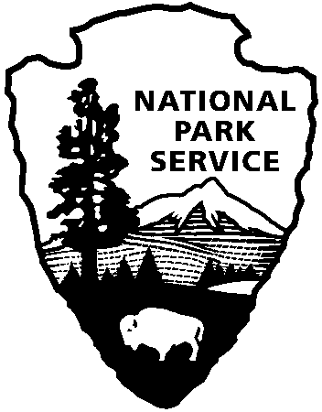
National Park Service
U.S. Department of the Interior

Release Date: August 23, 2017
Contact: Sally Hurlbert, sally_hurlbert@nps.gov, 540-999-3500 ext. 3300

Shenandoah National Park Trust Research Fellowship Program Opens for Applications

Luray, Virginia: Applications for the Shenandoah National Park Trust research fellowship program to facilitate and encourage scientific research in Shenandoah National Park will be accepted from September 15 to October 31, 2017. Funded by the Shenandoah National Park Trust, the grant supports field research in the physical, biological, ecological, social, and cultural sciences. The funding will support projects conducted in the park and help answer questions important to park managers. The grants are managed by Shenandoah National Park and up to $15,000 per grant will be awarded.

Shenandoah National Park offers an ideal natural laboratory in which to study a wide variety of research topics. Important science issues at the park include, but are not limited to, air pollution, water quality, habitat fragmentation, invasive exotic species, rare species conservation, recreation impacts on visitor experiences and natural resources, restoration of disturbed natural and cultural landscapes, protecting our cultural heritage, and an incomplete inventory of the park’s natural and cultural resources. Shenandoah National Park offers a diversity of landscapes across nearly 200,000 acres, including hardwood forest, rocky outcrops, mountain streams, and open meadows.

The research grant program is open to applications from undergraduate and graduate students, college and university faculty, state and federal agency scientists, private-sector research professionals, and others with appropriate backgrounds and credentials. To access the grant application and instructions, go to http://www.nps.gov/shen/naturescience/research-grant.htm. Applications will be accepted from September 15 until October 31, with grant award(s) announced December 15, 2017.

www.nps.gov

About the National Park Service. More than 20,000 National Park Service employees care for America's 417 national parks and work with communities across the nation to help preserve local history and create close-to-home recreational opportunities. Visit us at www.nps.gov, on Facebook www.facebook.com/nationalparkservice, Twitter www.twitter.com/natlparkservice, and YouTube www.youtube.com/nationalparkservice.

